Solve Me First
Platform: HackerRank
Language: C
Module 1, Question 2

Problem Link
https://www.hackerrank.com/challenges/solve-me-first/problem

Problem Statement
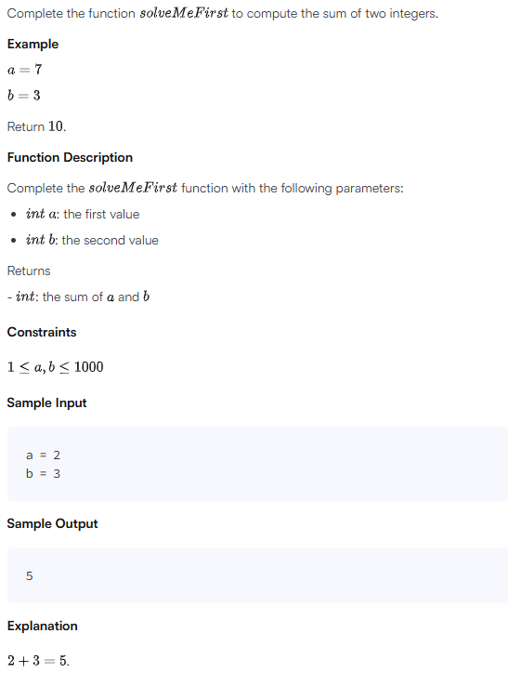

C Code
#include <stdio.h>

int solveMeFirst(int a, int b) {
return a + b;
}

int main() {
int num1, num2;
int sum;
scanf("%d %d", &num1, &num2);
sum = solveMeFirst(num1, num2);
printf("%d", sum);
return 0;
}

Screenshot of Successful Submission



